Hebrew SeniorLife Administrative Policy & Procedure

Policy Title | Management of Non-Marcus Institute Sponsored Awards
Responsible Department: | Hinda and Arthur Marcus Institute for Aging Research
Original Effective Date: | 8/1/2019
Review/Revised Date: | 5/16/2022
Supersedes: | 12/15/20, 1/16/2020
Approved By: | Kathy Tasker, Vice President, Sponsored Award/Research  Administration

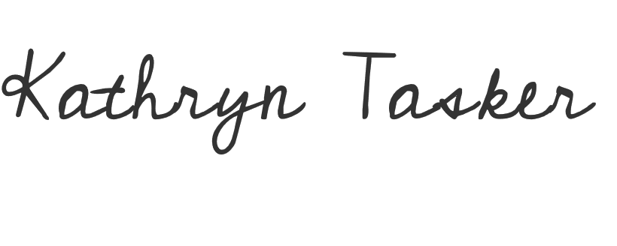
I. PURPOSE:

The purpose of this policy is to provide Hebrew SeniorLife (HSL) leadership and non-Marcus Institute staff procedures for proper management of sponsored awards. This policy will help ensure that all sponsored awards are managed properly and in compliance with sponsored award policies and procedures, and that all HSL departments are accountable for following these sponsored award policies and procedures.

II. SCOPE :

This policy applies to all HSL staff (exclusive of Marcus Institute staff).

III. POLICY:

HSL recognizes that sponsored awards provide significant resources to enhance HSL’s ability to provide programs and services. HSL will seek sponsored awards programs and services that
are aligned with HSL’s strategic plans or other programs that are determined by HSL’s Senior
Leadership Team to further HSL’s mission.

IV. PROCEDURES:

HSL Development, Sponsored Award/Research Administration, Legal/Compliance, and Fiscal Services work to support the development, submission, and management of sponsored awards from all external funders, including federal, state, and local agencies, foundations, and corporations. Sponsored awards differ from gifts and follow different policies and procedures. If a staff member is unsure about the nature of an award they should contact the Director, Institutional Giving, Sponsored Award/Research Administration office, or review HSL’s Sponsored Award Distinction Policy (available on the HUB or by request from the Development Department) for additional clarification.

HSL reserves the right to withdraw an application or to reject an agreement that was not managed in accordance with the following procedures.

1. All Principal Investigators (PIs – i.e. the HSL staff member who is leading on the grant and grant deliverables) must receive approval from the appropriate Senior Leadership Team
1

member prior to soliciting any sponsored award (i.e. from a private foundation, government agency, or other entity). Non-Marcus PIs must be a member of HSL’s Senior Staff.

2. All sponsored award submissions should be made under the Hebrew Rehabilitation Center entity unless otherwise approved by HSL’s General Counsel and Chief Compliance Officer (or designee), Vice President, Sponsored Award/Research Administration, and Vice President of Finance, Healthcare Services prior to submission.

3. All sponsored award submissions should be appropriate and directly related to HSL’s strategic plans.

4. All sponsored award budget submissions that include allocations for staff time must include HSL’s federally negotiated fringe rate, currently 27.5%.
5. When a sponsored award allows Indirects to be taken, HSL will expect that the full amount be taken (46% Non-Marcus Sponsored Awards and 60% for Marcus Sponsored Awards). Both rates are based on actual general ledger expenses used in the last rate negotiation. If the sponsor does not allow the full rate, but allows a different rate, that rate should be taken. Documentation of sponsor IDC rates will be required at time of award set-up.
6. In regards to cost sharing, if it is not required, HSL should not commit to cost sharing in the actual budget submitted to the funder. Instead, any additional support should be referenced in the narrative sections in a general way. If an actual cost share is required, it should not exceed the required amount detailed on the budget form submitted to the funder. Any required cost shares must be approved by Jim Hart or Lou Woolf. Please see the following link for directions: https://www.marcusinstituteforaging.org/resources/research-administration/non-marcus-institute-sponsored-awards
7. At the time of award all sponsored award agreements should be reviewed and approved by HSL’s Chief Compliance Officer and General Counsel prior to signing. All sponsored award agreements must be signed by either a) the President/CEO; b) Chief Sponsored Awards Officer, Hebrew SeniorLife or c) Vice President of Finance, Healthcare Services. Any other signatories must be approved by HSL’s General Counsel and Chief Compliance Officer.

8. All sponsored award agreements will be subject to inclusion of the following language: Please make checks payable to Hebrew Rehabilitation Center, c/o Hebrew SeniorLife and mail directly to the following address:

Hebrew Rehabilitation Center, c/o Hebrew SeniorLife
Attention: Naysa Mejia, Marcus Institute Grant Accountant
1200 Centre Street
Roslindale, MA 02131

9. As noted in Summary of Responsibilities, below, ALL sponsored award payments, vendor payments, and reimbursements are processed through Sponsored Award/Research Administration. Vendors with questions regarding payment(s) should be directed to the Chief Sponsored Awards Officer, Hebrew SeniorLife.
.
10. Any overspending, uncovered fringe, or cost sharing that occurs on a sponsored award must be covered by the PI’s home department.
11. All sponsored award applications that involve a budget must be communicated with the appropriate grant manager in Marcus for review and approval at least 2 weeks prior to the submission date. If state or federal flow through dollars are possible, grant manager needs to be advised at least 6 weeks prior or as soon as the PI determines to pursue the funding opportunity.

Summary of Responsibilities

Director, Institutional Giving
- Oversee the proposal development and submission of all sponsored awards for HSL (non- Marcus), including all sponsored awards where HSL is not the primary grant applicant (i.e., subcontracts/subawards).
- Coordinate and review matters, as necessary, with various HSL departments that are involved in sponsored award administration and compliance, including PIs, Research Administration, Fiscal Services, and Legal/Compliance.
3. Inform all Non Marcus PIs or Program Directors of the policies and procedures relating to the solicitation, acceptance, and stewardship of non-Marcus Institute sponsored awards.
4. Oversee stewardship of non-Marcus Institute sponsored awards, including working with PIs to ensure non-financial sponsored award reporting requirements are met and potential changes/revisions are communicated to the granting agency and approved before any changes are made to the project.

Sponsored Award/Research Administration
1. Administrative oversight of sponsored awards, including working with PIs and Vice President of Finance, Healthcare Services to ensure awards are managed and spent in accordance with specific sponsored award financial policies and in a manner satisfactory for audit purposes.
2. Serve as the centralized resource for questions regarding the administration, compliance, terms and restrictions of a sponsored award, including setting up accounts and communicating account information to PIs.
3. Process sponsored award payments, vendor payments and reimbursements (for example, invoices for activities completed as part of sponsored award requirements) in accordance with HSL’s Reimbursement, Purchasing and Accounts Payable Policy & Procedures for sponsored awards.
4. Report sponsored award fund balances to PIs on a monthly basis.
5. Prepare all financial reports utilizing the general ledger and required back up documentation to comply with financial cost account standards for financial reporting.

Principal Investigators (PIs):
- Project and budget oversight of sponsored awards, including ensuring sponsored award activities are completed, and completed in accordance with the sponsored award budget.
- Notify Sponsored Award/Research Administration and the Director, Institutional Giving in a timely manner if they reasonably believe that a) sponsored awards may require an extension or other significant changes to the award period; b) sponsored awards may require a budget revision; or c) unspent sponsored award funds may be returned to the granting agency.
3. Work with the Director, Institutional Giving to ensure sponsored award non-financial reporting requirements are met, including submitting a copy of any progress reports and/or other relevant funder communication to Sponsored Award/Research Administration.
4. Submit requests for grant reimbursements (i.e., paying of invoices) to Sponsored
Award/Research Administration in a timely manner, in accordance with HSL’s Reimbursement, Purchasing and Accounts Payable Policy & Procedures for sponsored awards.

Vice President of Finance, Healthcare Services:
1. Work with PIs and Sponsored Award/Research Administration to ensure sponsored awards are managed and spent in accordance with HSL and specific sponsored award financial policies and procedures.
2. Monitor sponsored award budgets against PI’s home department budget to ensure that funds are not falling into deficit and/or are not overspent.
General Counsel and Chief Compliance Officer (or designee):
- Advise on and approve terms and conditions within sponsored award agreements

